Cortland-Onondaga Federation of Kettle Lake Associations

One Year Membership Application

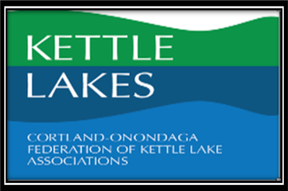

Name_____________________________________________________________ Date ___________
First Last
Address_____________________________City______________Zip______________

Business address _______________________City ______________state ______Zip__________

E-mail Address_______________________ Phone____________________
Is it OK to text you? ________ If yes #______________________

Corporate Partners at $150.00
–Recognition on print and web materials.
-Access to materials and sponsorship opportunities.

Watershed Partners – Other watershed groups at $75.00
–Recognition on print and web materials
-Access to materials and sponsorship opportunities.

Kettle Club Member– Suggested $25.00 donation
–Listing on website if desired, inclusion on email notices.
-Advance notice about workshops and other lake related activities.
-Set of unique Kettle Lake Note Cards.
-Opportunity to meet the speakers in a private setting.

If you are interested in being actively involved in the lake association, please e-mail Tom Cappa at tcappa@hotmail.com or, indicate your interest on the reverse side of this form.

If you have any questions or concerns, please use back to communicate to us.

Please Make your check to: COFOKLA Mail this completed application and check to:
Tom Cappa
326 Long Road
Tully, NY 13159

NYS Charities Bureau (Registration # 44-89-36).
NYS Charities Bureau Legal Statement: A copy of our most recently filed financial report is available from the Charities Registry on the New York State Attorney General’s website (www.charitiesnys.com) or, upon request, by contacting the New York State Attorney General, Charities Bureau, 28 Liberty Street, New York, NY 10005, or us by emailing cofokla@gmail.com. You also may obtain information on charitable organizations from the New York State Office of the Attorney General at www.charitiesnys.com or (212) 416-8401

